SWE20001 – Managing Software Projects

Learning Summary Report

DYLAN JARVIS (10209318)

**Portfolio Submission Due**

All Grades: Week 14 Mon (7th Nov 2022), 9:00am

**Portfolio Interview Dates**

Distinction / High Distinction: Week 14 Tue – Fri (8th – 11th Nov 2022), (15 minutes per student, book your interview time on Canvas)

Self-Assessment Details

The following checklists provide an overview of my self-assessment for this unit.

|  |  |  |  |  |
| --- | --- | --- | --- | --- |
|  | Pass (D) | Credit (C) | Distinction (B) | High Distinction (A) |
| Self-Assessment (please tick) |  |  |  |  |

*Self-assessment Statement*

|  |  |
| --- | --- |
|  | Included (please tick) |
| Learning Summary Report |  |
| **All** Pass Tasks are Compete on Canvas |  |

*Minimum Pass Checklist*

|  |  |
| --- | --- |
|  | Included (please tick) |
| All Credit Tasks are Complete on Canvas |  |

*Minimum Credit Checklist, in addition to Pass Checklist*

|  |  |
| --- | --- |
|  | Included (please tick) |
| Interview booked |  |
| All Distinction Tasks are Complete on Canvas |  |
| Other pieces (please specify) | - |

*Minimum Distinction Checklist, in addition to Credit Checklist*

|  |  |
| --- | --- |
|  | Included (please tick) |
| 81 HD Software Project Document [Plan, Design, QA] meet HD criteria and standards |  |
| 82 HD Research Article / Essay meets HD criteria and standards |  |
| Other pieces (please specify) | - |

*Minimum High Distinction Checklist, in addition to Distinction Checklist*

# Declaration

I declare that this portfolio is my individual work. I have not copied from any other student’s work or from any other source except where due acknowledgment is made explicitly in the text, nor has any part of this submission been written for me by another person.

Signature:

# Portfolio Overview

This portfolio includes work that demonstrates that I have achieve all Unit Learning Outcomes for SWE20001 Unit Title to a **HD** level.

I think the work I have completed in this unit is able to collectively demonstrate an in-depth understanding of project management using the scrum model. All tasks, including the group tasks were completed by me to a high standard, going above and beyond what was required for the passing mark. Only 1 task throughout the semester was marked as “resubmit” (because I forgot a key part), while the rest were complete on the first try.

Below is a list and brief description of the key evidence I have for going above and beyond the requirements of the unit:

1. A screenshot of a computer

   Description automatically generated with medium confidenceA screenshot of a computer

   Description automatically generated with medium confidenceGitHub tutorial videos – having used GitHub before I recorded myself cloning into and uploading stuff to the repository for the rest of the group members since a few of them were new to the tool:
2. Consulting the ISO standards – as shown in task 07P, I consulted and followed the requirements provided in the ISO standards to provide strong justification for choosing our definition of done.
3. Team leader – I conducted the team meetings and organised most of the work for the unit. I was responsible for the initial program design which was consistent with the end product. Examples of team leadership are shown in the following discord 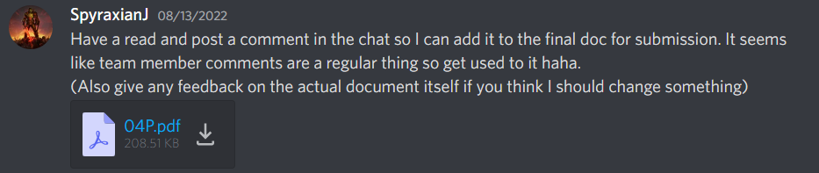Table

   Description automatically generated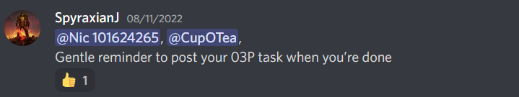correspondences:
4. Performing tests and benchmarking – I created a survey with Survey monkey and managed to get 7 people to fill it out after using our program interface. I then took this feedback and used it to help redesign the reporting templates.
5. Additional requirements for Pass project – I was responsible for pushing the implementation of pdf reports above and beyond the required csv reports for the basic project. Furthermore, we were ablet o set it up to autogenerate reports and send them to a google drive, something that would be particularly helpful in a real-life setting. Finally, we had a few extra popups and alerts which would inform the user of low stock after a sale, as well as a weekly report which would suggest what to buy to fill up reduced inventory items.

In summary, I believe that in doing the bulk of the documentation work of the group as well as substantial coding and designing for the project, I achieved the goals of this unit to a HD standard. Furthermore, by taking the leadership position and even guiding other team members through the use of collaborative tools, I extended beyond the requirements of the unit and gained an in-depth understanding of the scrum method of agile development.

# Reflection

## The most important things I learnt:

The power of communication and team management. I thought our team had one of the strongest and most productive setups purely because we were able to divide up meaningful responsibility which allowed each member to work throughout the semester. Furthermore, by keeping up constant communication I was able to ensure each team member felt some amount of accountability and thus kept them working throughout the semester.

## The things that helped me most were:

From the project point of view: Online resources for using the ignition software as well as Nic – another team member – who also had high proficiency with the tool we were using.

On the documentation side of things: ISO standards as well as the tutorial explanations provided by the tutor were extremely useful in understanding what would be acceptable for things like “definition of done”.

## I found the following topics particularly challenging:

Completing the definition of done section was one of the most challenging sections as it required consulting the ISO standards to perform it to a high level. Furthermore, it was surprisingly challenging to come up with metrics which were both a balance of realistic from an industry perspective but also realistically achievable and testable for this unit. In a nutshell: Creating SMART goals.

## I found the following topics particularly interesting:

The overall justification for using the scrum method of development. This was really highlighted for me during my HD report comparison between the two software development models. I found it very interesting to learn about their differences, but more so where the waterfall model has an advantage over the scrum, until then I was under the impression that the scrum model was set to replace the waterfall, but as it turns out, they are distinctly different and have certain places where they are more useful.

## I feel I learnt these topics, concepts, and/or tools really well:

Tools:

GitHub, though I already knew how to use it.

Ignition: the platform we used for the software design, this was new and never seen before, but after developing the project in it I was very comfortable with the interface as well as many of the functions is comes with.

Trello, I was not familiar with this tool either, however I was forced to use it to do task tracking and found it quite intuitive.

Concepts:

Scrum method for agile development. I have used a kind of similar method in an industry placement, but now I have a much better understanding of how its supposed to work and why it is so effective and flexible.

Team management, by taking the leadership role I was very on top of prompting communication, managing expectations, and also redistributing work where necessary, for example if someone got sick.

## I still need to work on the following areas:

In relation to time management, I could have still improved upon how much time was spent between documentation and implementation. Sometimes, in order to submit a group task I would have to leave a sprint task unfinished for the day.

Also just generally keeping to a daily schedule of work during the sprint was difficult, though I tried, other units often got in the way of constant work schedule.

## This unit will help me in the future:

I have recently had a grad application for a software role. If I take it, this unit will help me immensely in understanding both the process and the expectations of working in a software team using something similar to the scrum model. As mentioned, I had a similar experience during a placement, however I wasn’t aware that’ what model we were using and I think after this unit I will be even more effective at communicating and working in a team to achieve a project delivery.

## If I did this unit again I would do the following things differently:

I wouldn’t do much differently, however one could always put in more effort. As mentioned in the need to work on section, keeping to a stricter working schedule during the sprint would have been even more realistic to an industrial setting, however in the real world it is likely that I wont have other units or tasks getting in the way and thus it will be much easier to achiev this goal.